**NEURAL NETWORKS AND DEEP LEARNING**

**ICP 7**

Name: Yukthi Sravani Tummalapalli

Student ID: 700746296

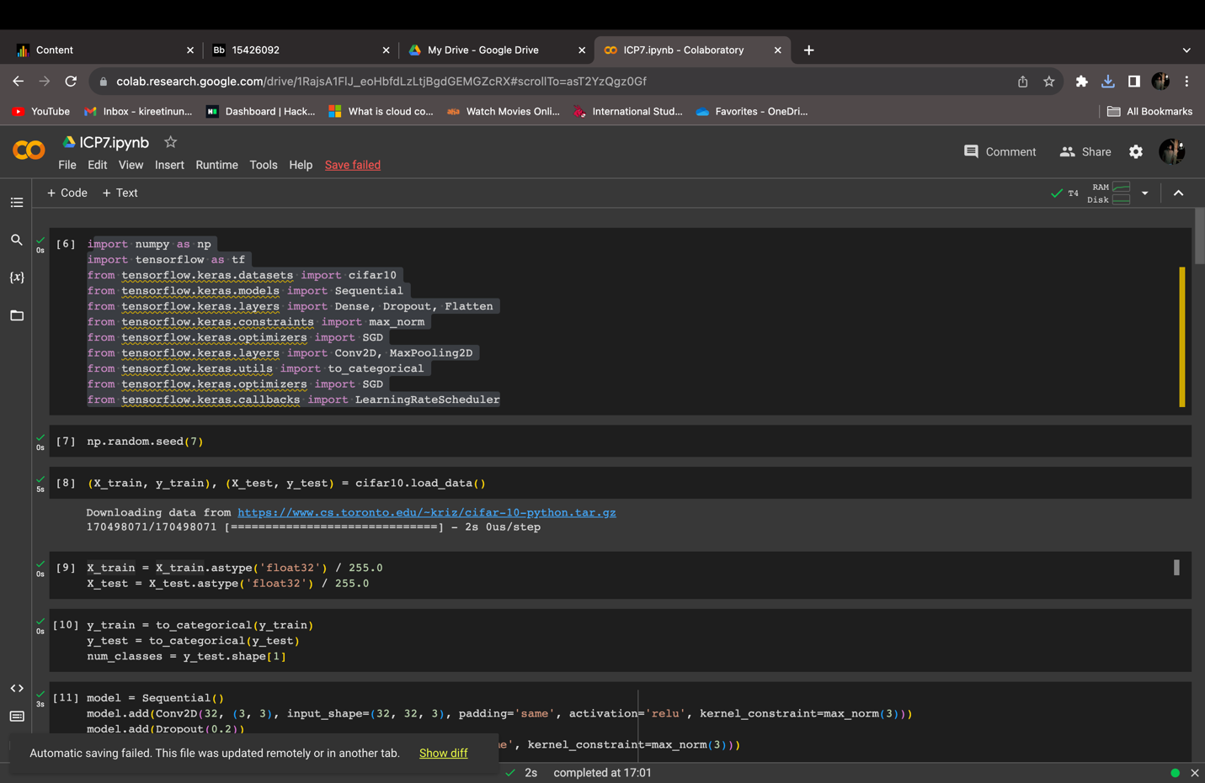

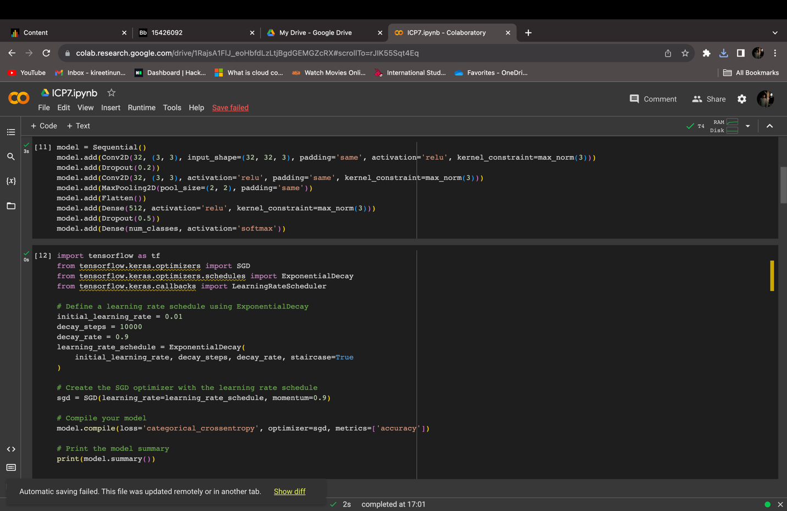

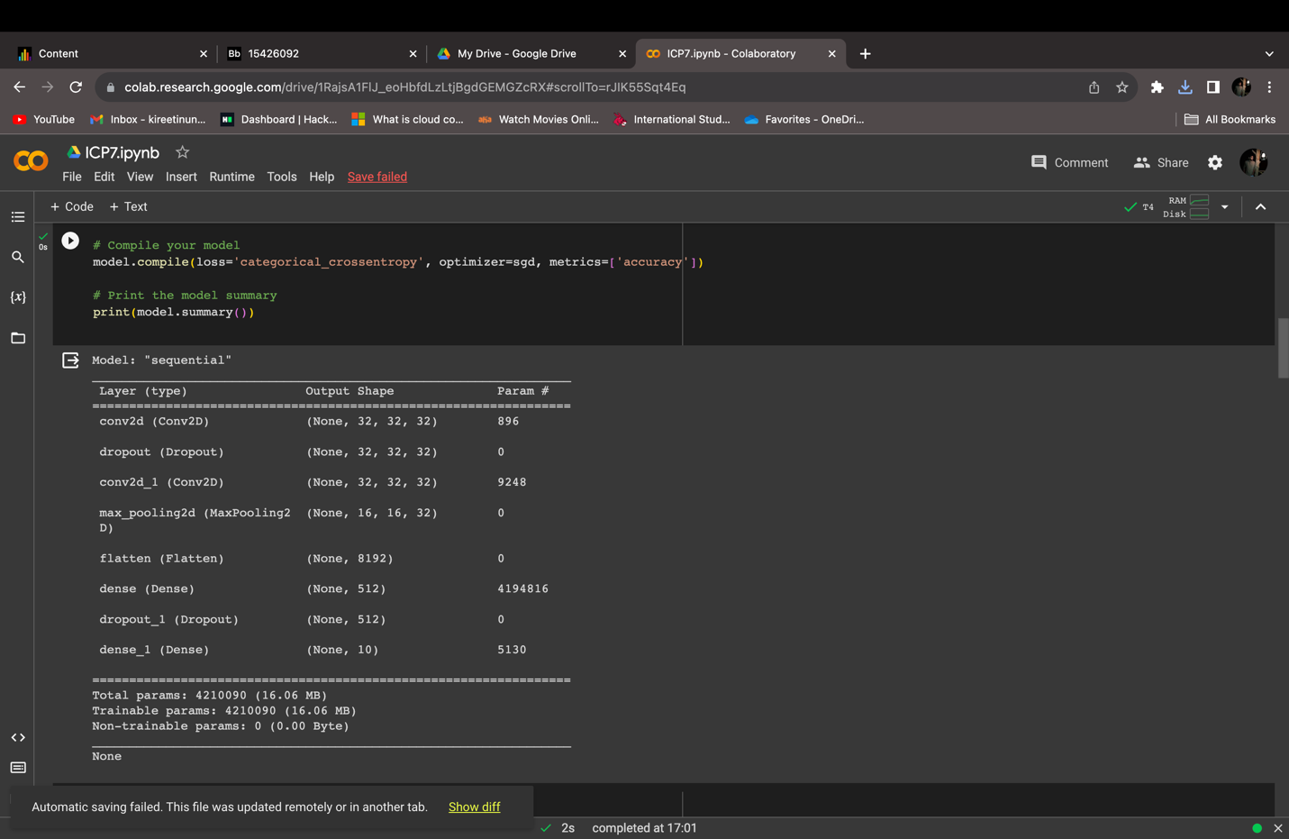

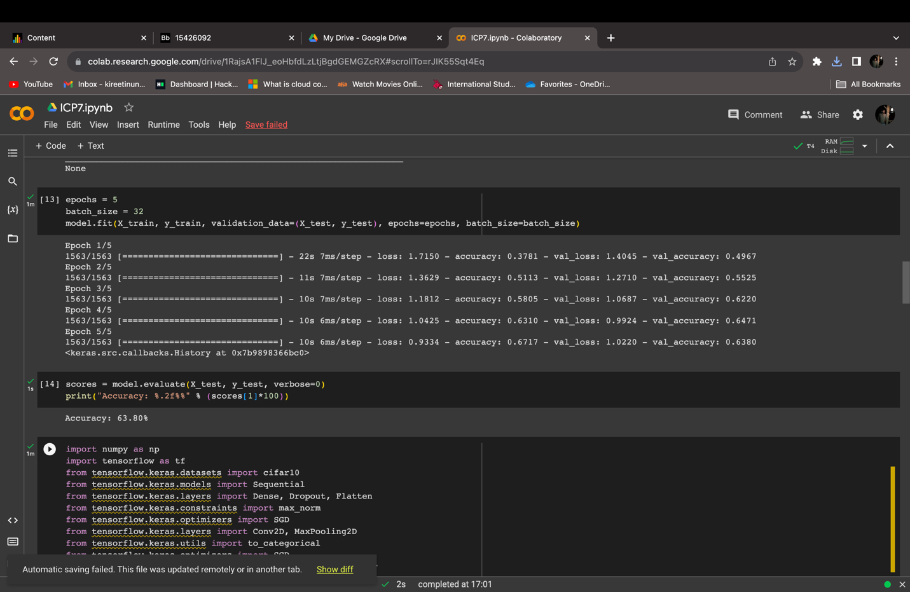

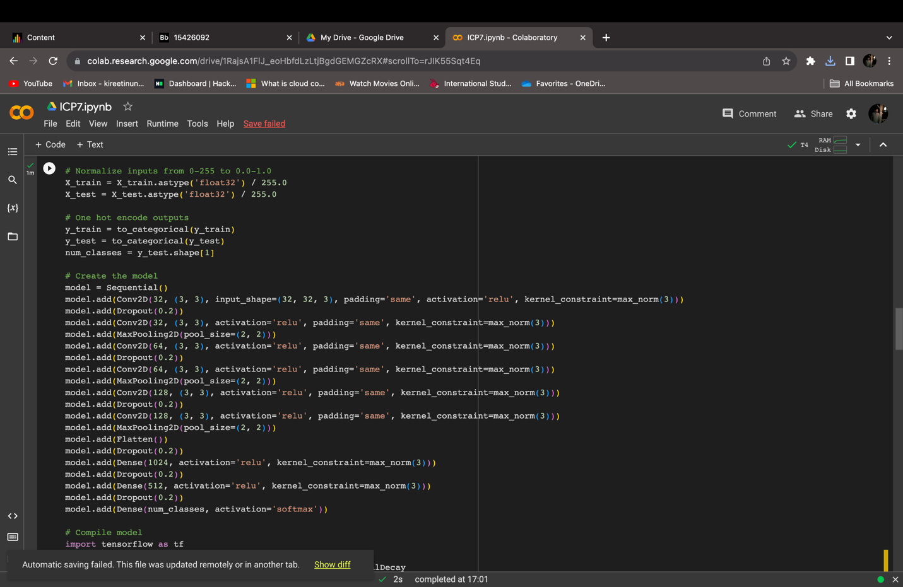

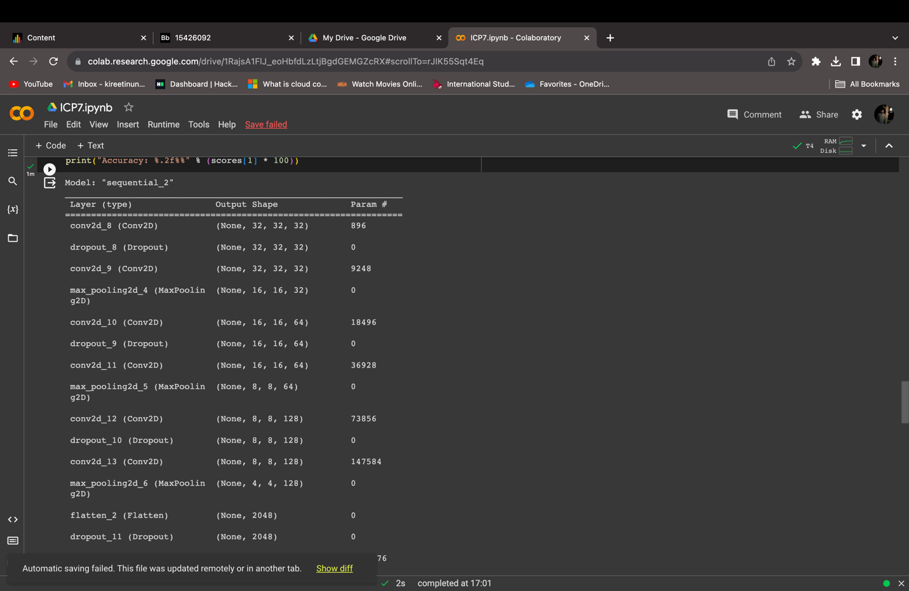

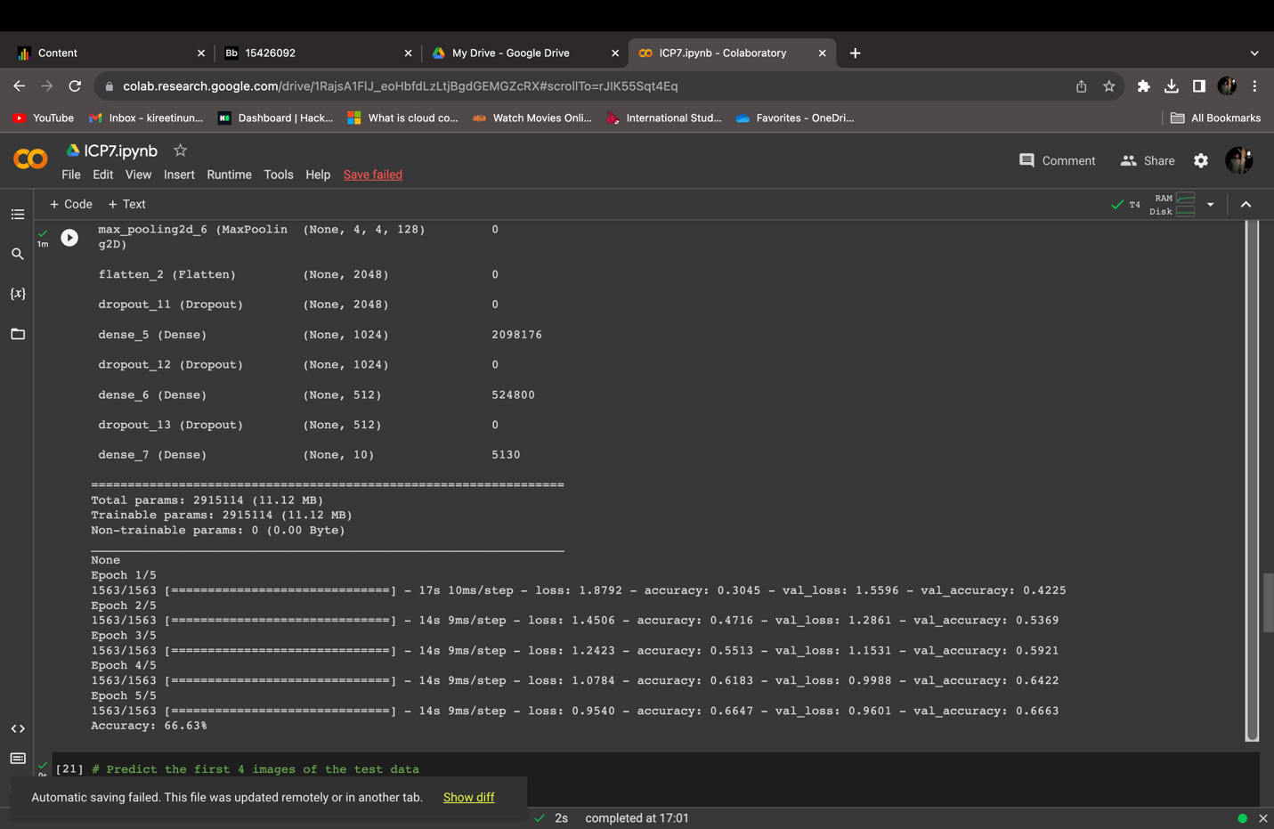

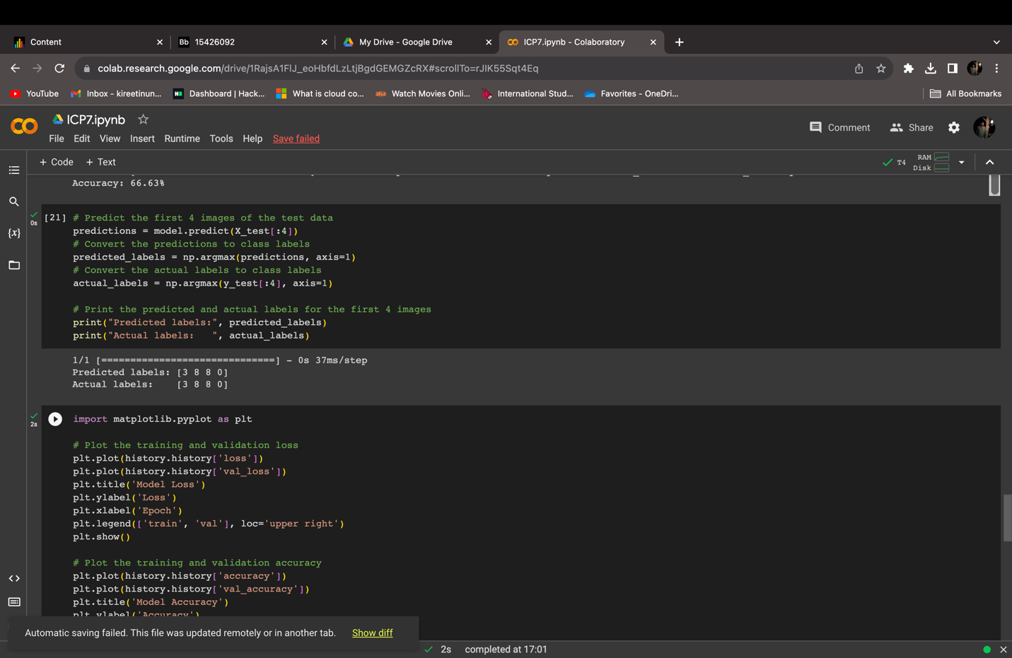



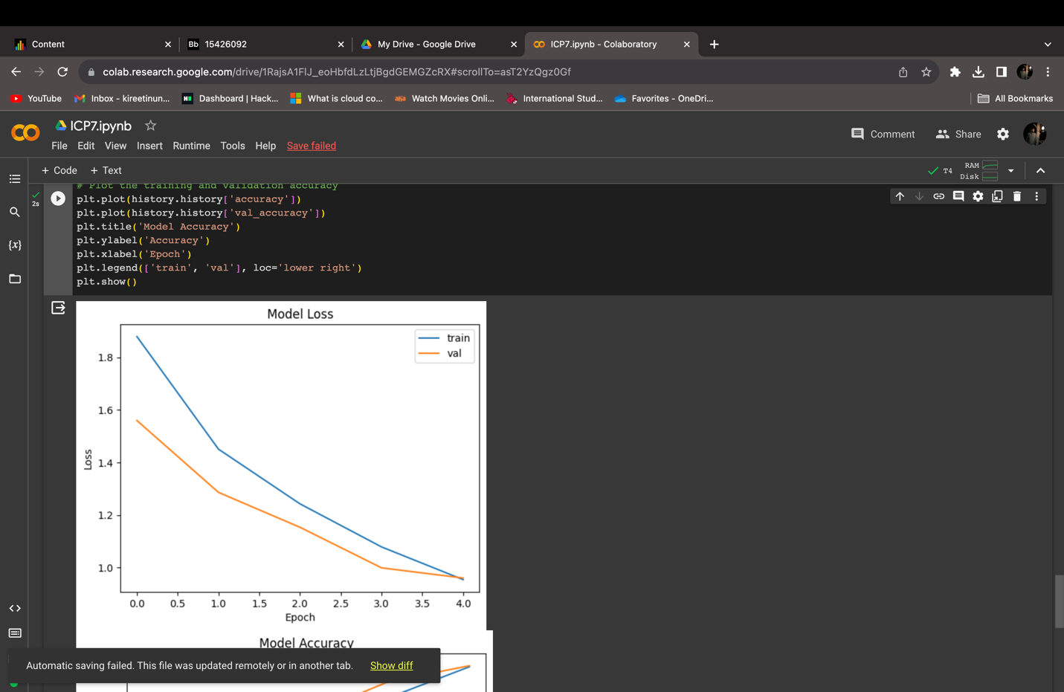

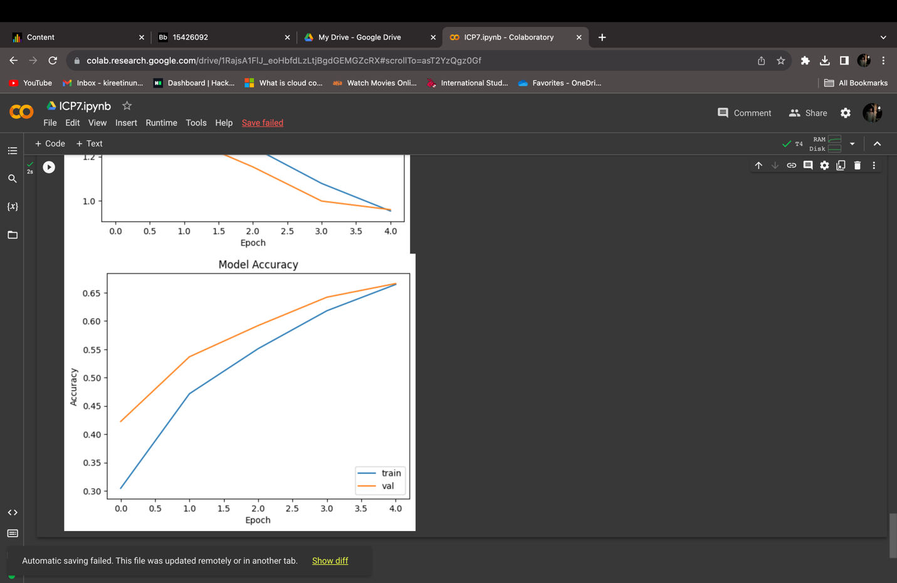

GitHub Link: <https://github.com/yukthi16/ICP7>

Video Explanation Link: <https://drive.google.com/file/d/1OIrJ4Bs276GO5vYDcb8DPlBWzkRQ-5MS/view?usp=drive_link>